* Many important things are deemed as implementation-defined by the standard. For example,



If the char has only 8 bits, then 1256 will be converted to 232. (No idea how?)

* Many assumptions about implementation-defined features can be checked by stating them as static assertions. For example,



* A construct is deemed undefined by the standard if no reasonable behaviour is required by the implementation. For example,

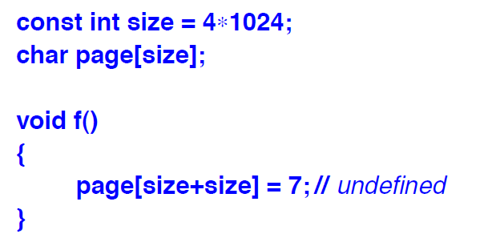

Plausible outcomes of this code fragment include overwriting unrelated data and triggering a hardware error/exception.

An implementation is not required to choose among plausible outcomes.